Kristen’s Quarter 3 Newsletter
Rainshadow CCHS 775-322-5566 |  |  | 24 Feburary 2014 Volume 1, Issue 1
Contents  Introduction 1  U.S. History 1  World History 2  Geography 2  Upcoming Events 2  Leadership 3  Rock Around the Clock 3  Of Special Interest  Visit our website to help raffle raise money for prom:  raffle4prom.weebly.com  Interested in buying this year’s Rainshadow t-shirt and/or sweatshirt? Ask your student to bring home a pre-order form.  If you know any former RCCHS students please let them know about our “Alumni Ice-cream Social” coming up on March 7th. | 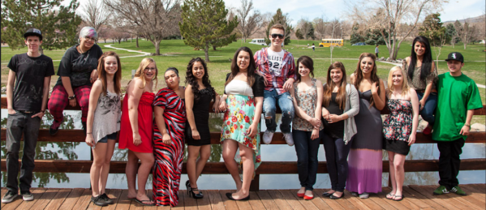
 | Introduction
Dear students, parents, and guardians:
As most of you know Rainshadow is going through accreditation this year. As a part of this process many of you have filled out parent/student surveys about our school. As the teachers reviewed the results of these surveys, I noticed that for the most part parents would like us, as teachers, to find more ways to communicate with you. Students, you were interested in knowing what is coming up in your classes.
In an effort to be more communicative I have decided to put out a quarterly newsletter. My goal is to publish a newsletter with information on what is going on in each of my classes, and some general information about school news during the middle of each quarter. Hopefully this will help everyone stay more informed, and feel more up to date.
If you have any questions, concerns, or anything you feel should be published in the newsletter, do not hesitate to contact me. Email is usually the fastest way to do this, but you can also call the school.
Contact Information:
kristen@rainshadowcchs.org775-322-5566

 | U.S. History
U.S. History is generally an 11th grade class.
Right now we are finishing an essay examining the role that yellow journalism played in starting the Spanish-American War. This is in the first part of our “American Imperialism & World War I” unit. The students have been working hard to use the Jane Schaffer writing method to write a persuasive essay due this week. I am looking forward to reading them, and seeing how your writing has improved since the Declaration of Independence essay that we wrote in the first quarter of the school year.
Coming up, we will be reviewing U.S. involvement in World War I. We will start by reviewing last year’s World History lessons on WWI, and then move into learning about how the war was affected by the involvement of the United States. We will also look at how the war played a role in the U.S. economy, the lives of American women, the Great Migration, the draft, and wartime propaganda. We will finish this unit with a lesson on President Wilson’s 14 points, specifically his idea for the League of Nations.
Our next unit will be the Roaring 20’s. In this unit we will be watching The Great Gatsby (1974), and students will be creating a magazine about the 1920’s U.S.

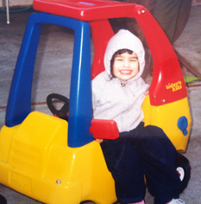  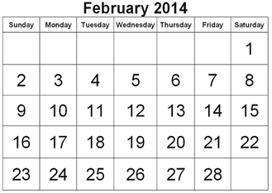  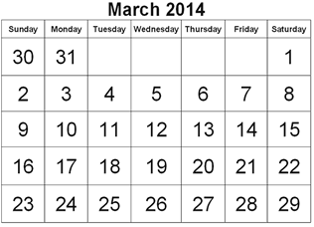  Baby Pictures  Every year we have a baby picture section in the yearbook. If you have baby pictures of your student you would like to share in the yearbook please email them to me at: kristen@rainshadowcchs.org | World History
World History is generally a 10th grade class.
In World History we just finished our unit on the Scientific Revolution & The Enlightenment. As a part of the end of this unit we read an excerpt from John Locke’s Two Treatises of Government. As you might imagine, this was a difficult text to get through with high school sophomores, but the students were champs! They never gave up on trying to understand the chapter we were reading (“Of Tyranny”). Afterwards, they had to write an essay about the difference between a good king and a tyrant according to John Locke. Finally, we just took a quiz, ending the unit.
Coming up, we will be starting our unit on Revolutions. This is a thematic unit, rather than going in chronological order, that covers the French, Russian, and Cuban Revolutions. We also cover a recent revolution at the end of the unit, which this year will be Venezuela. I have a friend that is currently teaching at a school in Venezuela who is willing to Skype with the students to give them some information on what is happening from the point of view of someone living there!

 | Geography
Geography is typically a 9th grade class.
In Geography we are in the middle of a unit that covers many different topics, including ecosystems, climate, and plate tectonics. Much of this is a necessary review from elementary school, because by their freshman year some of this information has become fuzzy to the students. Next week, the students will be participating in one of the most popular lessons I have taught at Rainshadow called “Snack Tectonics”, where we use snack foods such as graham crackers and fruit roll ups to demonstrate how tectonic plates move, and the results of their movement.
Coming up in my class will be our unit on East Asia. We will spend some time learning about the different countries in this region of the world, and their cultures. In addition, we will spend some time talking about the Ring of Fire.

 | Upcoming Events
February 26-28th
Scary Play
This play will be put on by our drama teacher, Pan, and Rainshadow students. Come check it out on any of these days at 7:00pm at Pan’s theater (2275 Dickerson Rd)
March 3-6th
Proficiency Testing
Students that are not testing will have a half day, and should not arrive at school until 12:00pm. Students that are testing should arrive at 8:00 am.
March 7th 5:00-7:00 pm
Alumni Ice-cream Social
Former RCCHS graduates can meet up and hang out.
March 20th
End of Quarter 3
March 28th-April 6th
Spring Break

Leadership |  |  | T-Shirt & Sweatshirt Sales  Leadership is selling this year’s school t-shirts at sweatshirts!  - Men’s t-shirt $15  - Women’s t-shirt $15  - Sweatshirt $25  If you are interested in buying a t-shirt or sweatshirt ask your student to bring home a pre-order form for you to fill out.  Proceeds will go to help the students travelling to Washington D.C. with Sam this summer.  The pre-order forms are due by March 6th.
Leadership is a class for students from any grade level.
In Leadership this quarter we are working on a plethora of different projects. Our candy-gram sales for Valentine’s Day earned us about $25 that will be going towards this year’s prom.
We are also working on a raffle to help us raise more funds for prom. The goal is to have a small meal of entrees for the students that match our 1950’s theme. Chris, the head of the culinary department, will be making sliders, ice cream sundaes, and other diner style food for the students. This past Friday, two students came around downtown and midtown Reno with me to ask local businesses to donate gift cards and other items to our raffle.
Raffle tickets will go on sale in March, and I will be asking each Leadership student to sell 4 tickets or more to help us reach our goal of $500. This money will go towards food and decorations for prom. Anything extra will go to Sam to help the students he is taking to Washington D.C. this summer. If you have any questions about the raffle, or want to see a list of prizes so far, please visit raffle4prom.weebly.com.
In March I will be asking some Leadership students to help serve food at our Alumni Ice-cream Social on Friday, March 7th. Students will need to stay from 4:00-8:00pm, but if they stay the entire time they will be released from school at 2:00pm the following week.

Rock Around the Clock – Prom 2014
This year the school voted on a 1950’s prom theme, which the Leadership students have decided to call “Rock Around the Clock”. The students have some great ideas about how to make prom this year better than it has ever been before!
We would like to have 2 parent volunteers to help chaperone/sell tickets at prom. If you are interested, please call or email me using the contact information on the first page of this newsletter.
If you own a small business, or know anyone that does, and you are willing to donate some items or gift cards for Leadership to raffle off as a part of our prom fundraiser, please contact me. So far we have many wonderful items up for grabs! Businesses that donate will have their business logo, and website posted in the “Sponsors” page of our website, as well as next to their prize on the “Prizes” page. Check out the website at raffle4prom.weebly.com.

